Data structures and Algorithms

Exercise 2: E-commerce Platform Search Function
Scenario:
You are working on the search functionality of an e-commerce platform. The search needs to be optimized for fast performance.
Steps:
- Understand Asymptotic Notation:
  - Explain Big O notation and how it helps in analyzing algorithms.
  - Describe the best, average, and worst-case scenarios for search operations.
- Setup:
  - Create a class Product with attributes for searching, such as productId, productName, and category.
- Implementation:
  - Implement linear search and binary search algorithms.
  - Store products in an array for linear search and a sorted array for binary search.
- Analysis:
  - Compare the time complexity of linear and binary search algorithms.
  - Discuss which algorithm is more suitable for your platform and why.

Understanding Asymptotic Notation:
Big O Notation
Big O notation is a mathematical way to describe how the runtime or space requirements of an algorithm grow as the input size grows. It provides an upper bound on the time, giving the "worst-case" scenario, which helps developers ensure their application will scale without crashing under heavy loads.
Search Scenarios
Best-case: The item is found immediately (e.g., at the first index). Both Linear and Binary search are O(1) in the best case.
Average-case: The item is found somewhere in the middle. Linear search is O(n/2) which simplifies to O(n). Binary search is O(log n).
Worst-case: The item is at the very end or doesn't exist. Linear search is O(n). Binary
search is O(log n).

CODE:
Main.java:
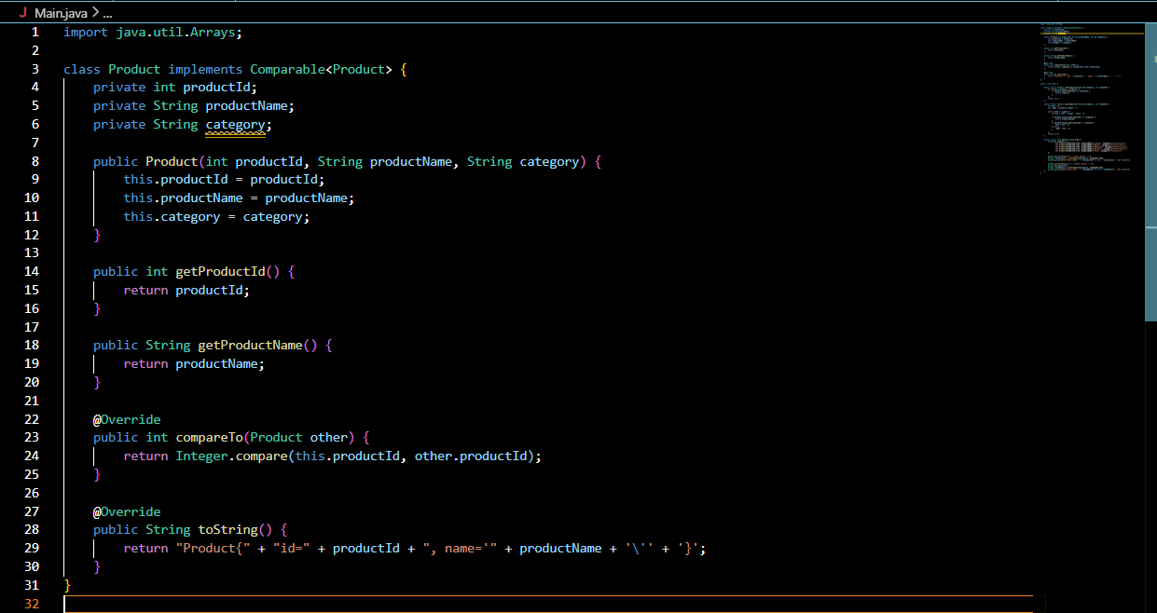

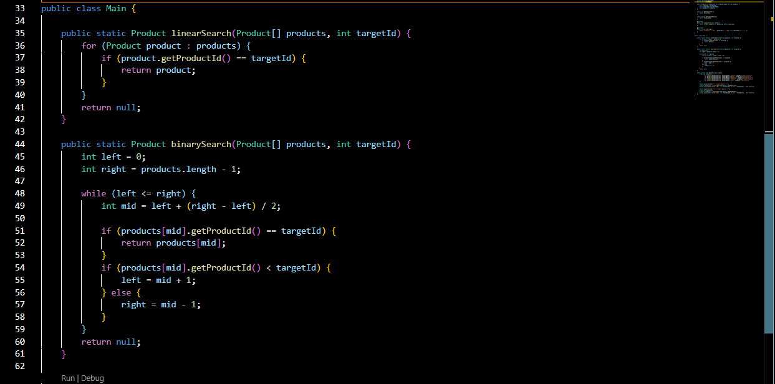

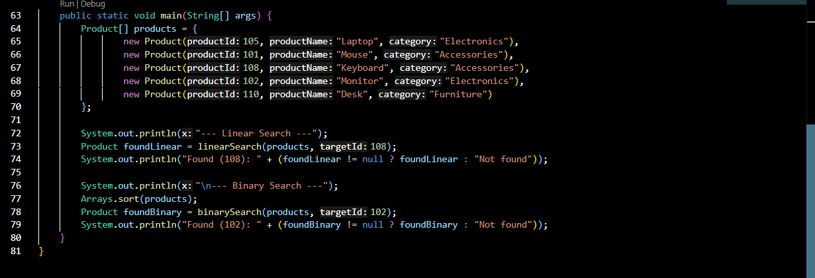

OUTPUT:
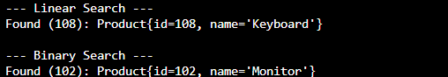

Analysis:
Time Complexity Comparison:
Linear Search: O(n). It checks every element one by one. If we have 1 million products, it
might take 1 million checks.
Binary Search: O(log n). It halves the search space every step. For 1 million products, it
takes at most ~20 checks.
Conclusion: For an e-commerce platform where fast performance is required and the product catalog is likely very large, Binary Search is far more suitable. The only caveat is that the product array must be kept sorted, which is a manageable trade-off for the massive gain in search speed.

Exercise 7: Financial Forecasting
Scenario:
You are developing a financial forecasting tool that predicts future values based on past data.
Steps:
- Understand Recursive Algorithms:
  - Explain the concept of recursion and how it can simplify certain problems.
- Setup:
  - Create a method to calculate the future value using a recursive approach.
- Implementation:
  - Implement a recursive algorithm to predict future values based on past growth rates.
- Analysis:
  - Discuss the time complexity of your recursive algorithm.
  - Explain how to optimize the recursive solution to avoid excessive computation.

Understanding Recursive Algorithms
Recursion is a programming technique where a method calls itself to solve a smaller instance of the same problem. It simplifies complex problems by breaking them down into identical, manageable sub-problems. Every recursive function requires a Base Case (a condition to stop the recursion) and a Recursive Case (the logic that moves the problem closer to the base case).

CODE:
FinancialForecasting.java
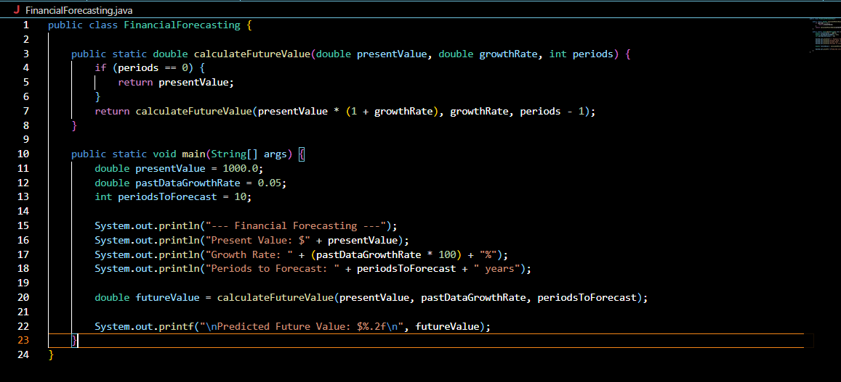

OUTPUT:
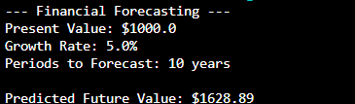

Analysis:
Time Complexity
The time complexity of this specific recursive algorithm is O(n), where 'n' is the number of
periods. This is because the function makes exactly one recursive call for each period until it hits the base case.
Optimization
In simple linear recursion like this, the main risk is a StackOverflowError if the number of
periods is extremely high. However, in more complex financial modeling where recursive calls branch out (e.g., exploring multiple investment scenarios resulting in an O(2^n) complexity), we optimize using Memoization. Memoization stores the results of expensive function calls in a data structure (like a HashMap) and returns the cached result when the same inputs occur again, preventing redundant calculations and drastically improving performance.

